Museum of the Bible & Basilica of the Immaculate Conception Trip
Registration
Seton Youth Ministry will be traveling on a school bus from our church to Washington D.C to visit the Museum of the Bible and the Basilica of the Immaculate Conception. This event is open to the entire St. Elizabeth Ann Seton Parish community.
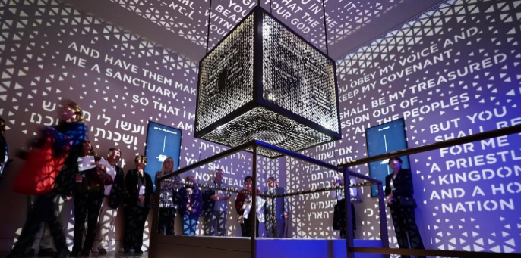
Image from inside the Museum of the Bible
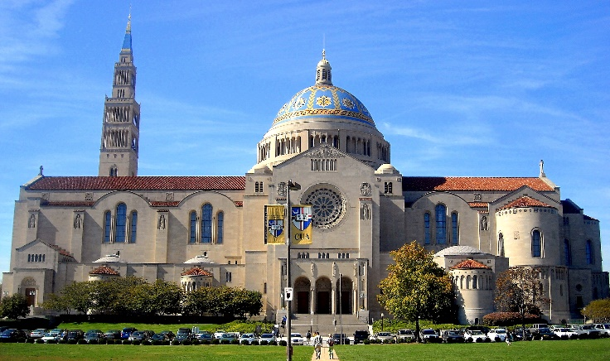
Image of the Basilica of the Immaculate Conception
Date: Saturday, April 21st
Departure time from St. Elizabeth Ann Seton Parish: 7:45am
Return time to St. Elizabeth Ann Seton Parish: 7:00pm
Cost for youths 19 & under: $25
Cost for those 20 & older: $40
Registration due March 25th by the 11 o’clock mass.
Youth Registration: Make checks payable to St. Elizabeth Ann Seton Parish & fill out the attached form.
Adult Registration: Make checks payable to St. Elizabeth Ann Seton Parish & fill out the below box:
Name: _________________________ Email: _________________________
Cell #: __________________________ Home #: _________________________
Emergency Contact Name & #:___________________________________________________

